HOW TO MAKE A WEBSITE

Step 1:
Start Apache and mysql from xampp control panel

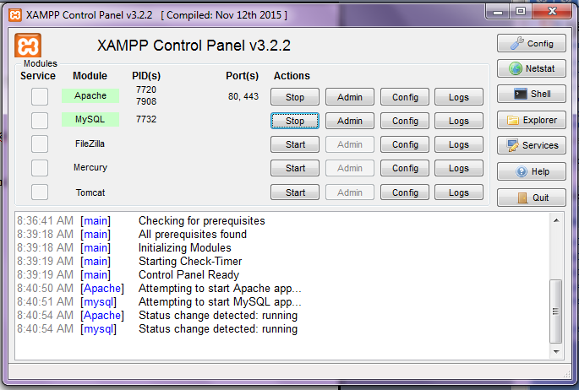

Step 2:
Go to localhost/phpmyadmin and create a new database

Step 3: Create the required tables
First column must always be id….set it to primary key and A_I (which is auto increment)

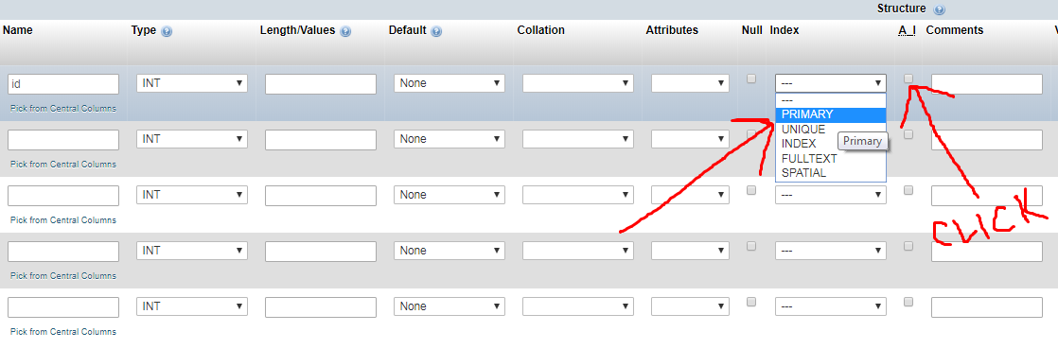

Now Database is ready.

Step 4:
Create your website’s folder in htdocs
Put your index.php file in here and all other files from now on

Step 5:
Now to create any page, it should start with :
<?php

session_start();

$conn=mysqli_connect(“localhost”,”root”,””,”your database name”);

if(!$conn){
die("Couldnot connect to server");
}

?>

$conn is your connection variable

IMPORTANT: EVERY PHP LINE ENDS WITH A SEMICOLON ( ; ) JUST LIKE IN JAVA

Step 6:
The website works in 3 stages:
1. Take data form user
2. Process it
3. Give output

Now taking data from the user is done by using forms only

Forms’ headers look as follows:
<form action=”backendfile.php” method=”post”>

Once the form is submitted, the data is sent through POST to the backendfile.php

(Every form has a submit button which is as follows:
<input type=”submit” value=”Press Button” /> )

(Data inside forms looks as follows:
<input type=”text” name=”username” placeholder=”ENTER NAME”/> )

Step 7:
Receiving data is done by using POST:
So inside backendfile.php,
First start session and establish connection with the database (Step 5)

Then, receive data as follows:

$username=$_POST[‘username’];

Step 8:
Now store data in the table as follows:

$sql=”INSERT INTO mytable VALUES (‘$username’)”;
$result=mysqli_query($conn,$sql);

OPTIONAL STEP:
If you wish to set a session variable, do the following:
Suppose we wish to set username in a session variable, then it looks as follows:
$_SESSION[‘username’]=$username;

This session variable will now be available on your entire webpage

Step 9:
Now we either give an output as follows:

echo “Data inserted”;

OR

Redirect as follows:

header(“LOCATION: nextpageURL.php”);

Step 10:
RETRIEVING DATA:

Now to retrieve data inside an html page,
Do the following:

First start session and establish connection (Step 5)

Declare HTML document:

<?php

//session establishment and connection

?>

<!DOCTYPE html>
<html>
<head>
<title>HI</title>
</head>
<body>

</body>
</html>

Now to give output, write php inside the body of the html as follows:

<?php

//session establishment and connection

?>

<!DOCTYPE html>
<html>
<head>
<title>HI</title>
</head>
<body>

<?php

$sql=”SELECT * FROM users”;
$result=mysqli_result($conn,$sql);

while($row=mysqli_fetch_assoc($result))
{
echo $row[‘username’].”<br>”;
echo $row[‘email’].”<br>”;
}

?>
</body>
</html>

And that’s it.

WEBSITE IS NOW READY!

Miscellaneous Queries:

Update Query:

$sql=”UPDATE tablename SET attribute1=’$variable’, attribute2=3 WHERE id=’$id’ ”;
$result=mysqli_query($conn,$sql);

DELETE QUERY:

$sql=”DELETE FROM tablename WHERE id=’$id’ ”;
$result=mysqli_query($conn,$sql);

